Short Title 1

**Title For Paper 2**

Christopher Kavanagh1,2

Jack W. Klein3

Harvey Whitehouse1

1 Centre for the Study of Social Cohesion, University of Oxford

2 Department of Psychology, Rikkyo University

3 Melbourne School of Psychological Sciences, University of Melbourne

**Author Note**

Funding for the project was supplied by the Freedom of Religion or Belief Leadership Network Foreign (FoRBLN) which was supported by the Commonwealth and Development’ Office’s UK Aid Connect Fund.

Correspondence Address: Christopher Kavanagh, Centre for the Study of Social Cohesion, University of Oxford, chriskavanagh@gmail.com

We have no conflict of interests to declare.

Short Title      2

Abstract

Insert abstract here.

*Keywords: keyword 1, keyword 2.*

Short Title      3

**Title**

Insert intro paragraphs here.

**Methods**

**Ethics**

The responses collected from respondents was collected on the Qualtrics platform with HIPAA compliant storage servers and then processed and stored securely with anonymised datasets. All participants were provided with study information, provided with researcher and ethic board contact details, and were required to complete a detailed consent sheet prior to participation. All procedures for the study complied with the regulations of the School of Anthropology and Museum Ethnography Research Ethics Committee (Oxford University) and received approval (Ref No: SAME_C1A_20_097). None of the authors have any conflicts of interests beyond participation in a research project that aims to promote Freedom of Religion or Belief Leadership across the seven countries that the samples are collected from.

**Data Accessibility**

The data used in all analyses reported in the manuscript are available to access on the Open Science Framework ([link](https://osf.io/z7swb/?view_only=e27e08dbc2234479b7381f358797ce8e)) with all identifying information removed.

**Sample**

We collected an initial sample of N = 1588 respondents from four countries: Gambia, Pakistan, Tanzania and Uganda. Our initial target was N=500 per country, with age and gender distribution matching national demographics. However, due to the length of the study, we were unable to achieve the desired sample size with representative demographic quotas for two countries (Gambia and Tanzania), so the representative criteria were gradually relaxed to increase the response rate.

We then used a combination of three low-quality indicators: a completion time of under 15 mins (the survey was anticipated to take 30-40 mins), a score of lower than 1.5 on SD for three sets of unrelated scales, and low-quality or irrelevant responses to open-ended questions. 96 respondents who scored on 2 or more of these indicators were automatically excluded. Those with only one low-quality indicator were manually reviewed prior to analysis and another 122 were excluded. A further 55 respondents were also found to be missing key variable scales and were also excluded. This left a final total of N = 1593. See Table 1 and Figures 1-5 for demographic details for each country.

Table 1. Demographics by Country

|  |  |  |  |
| --- | --- | --- | --- |
| Country | Sample Size | Age | Sex by % |
| Gambia | 232 | Mean = 38  Median = 34  Range = 19 - 90 | M = 62.9%  F = 21.9%  O = 15% |
| Pakistan | 504 | Mean = 33  Median = 31  Range = 18 - 40 | M = 52.38%  F = 47.62% |
| Tanzania | 352 | Mean = 36  Median = 34  Range = 18 - 84 | M = 51.99%  F = 42.89%  O = 5.11% |
| Uganda | 500 | Mean = 40  Median = 36  Range =18 - 92 | M = 41.20%  F = 54.00%  O = 4.8% |

Figure 1. Sample Size by Country

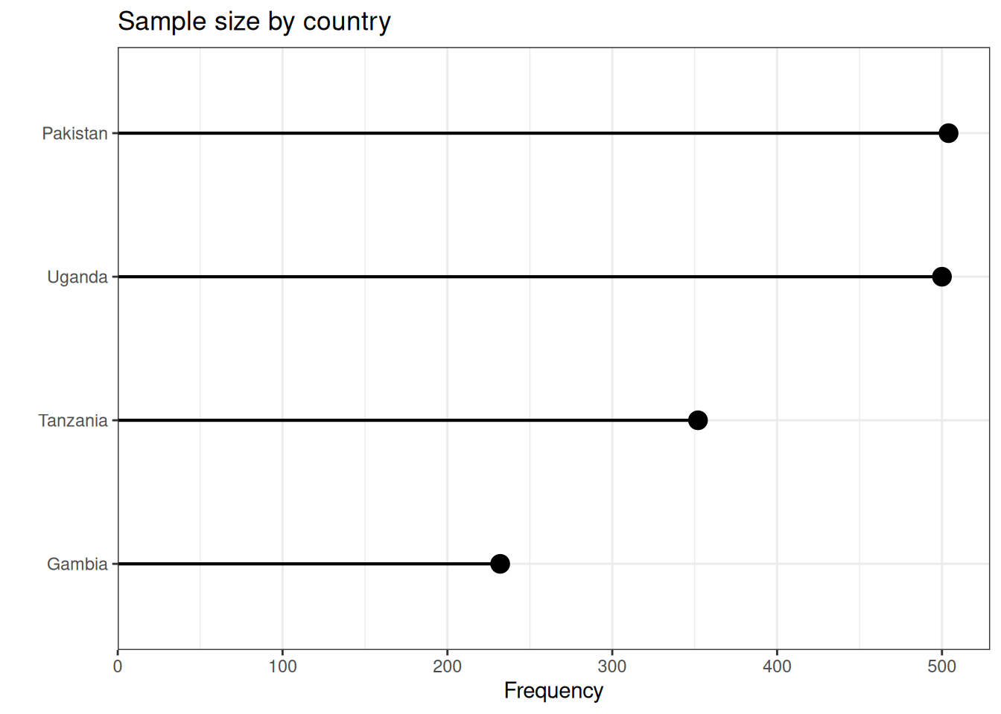

Figure 2. Age and Gender Distribution by Country

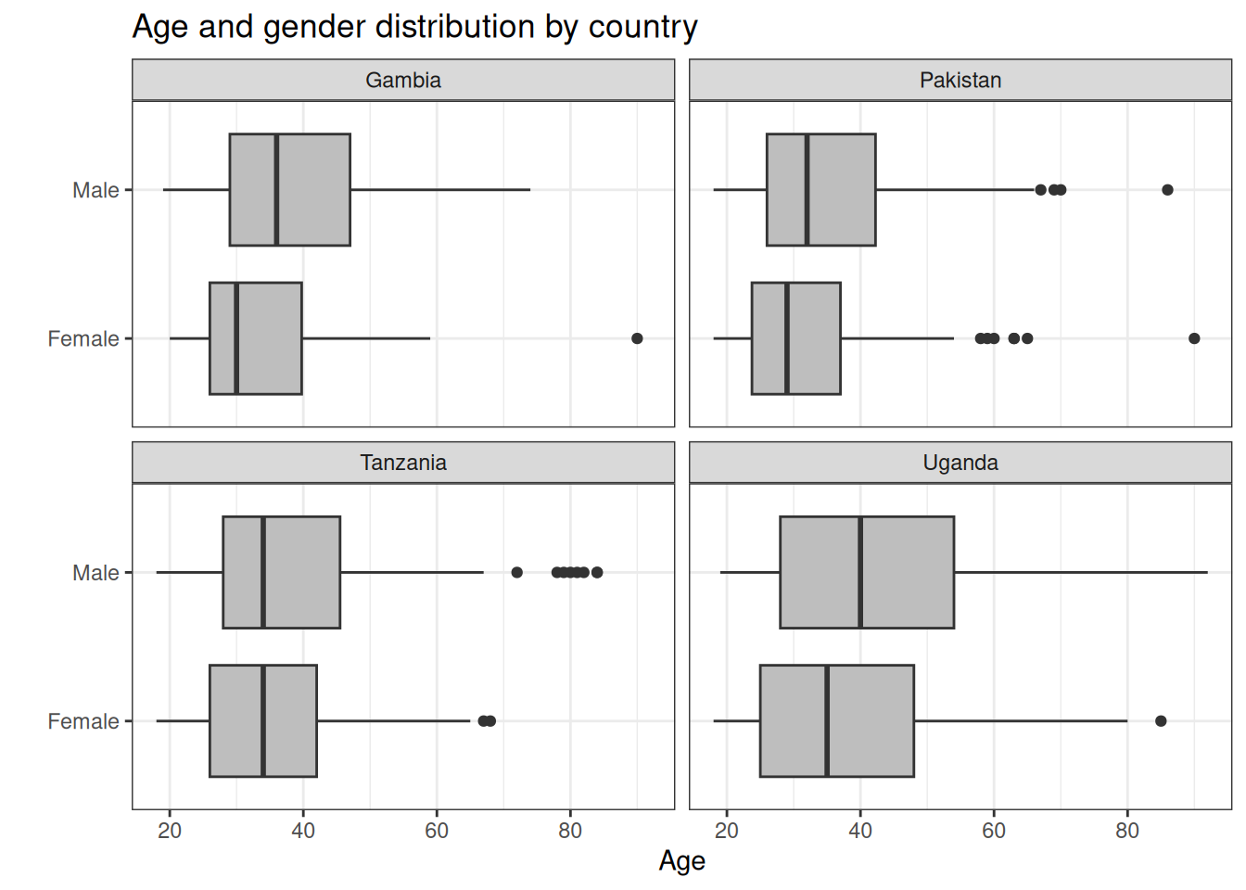

Figure 3. Socioeconomic Status by Country

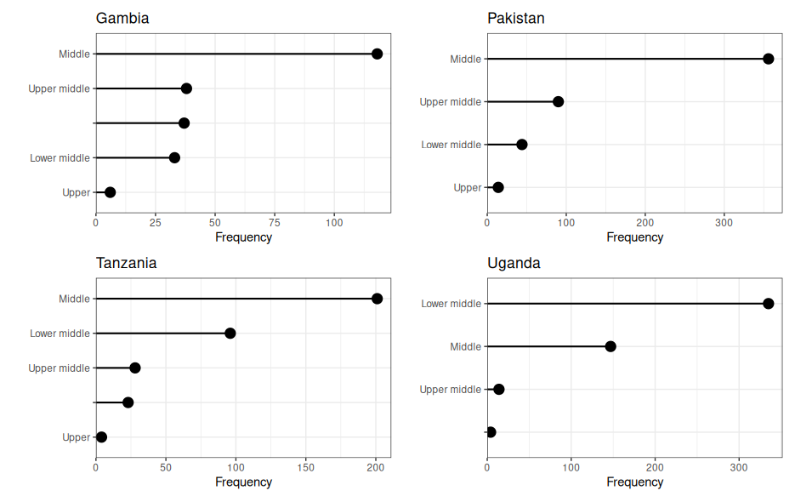

Figure 4. Distribution of Religion by Country

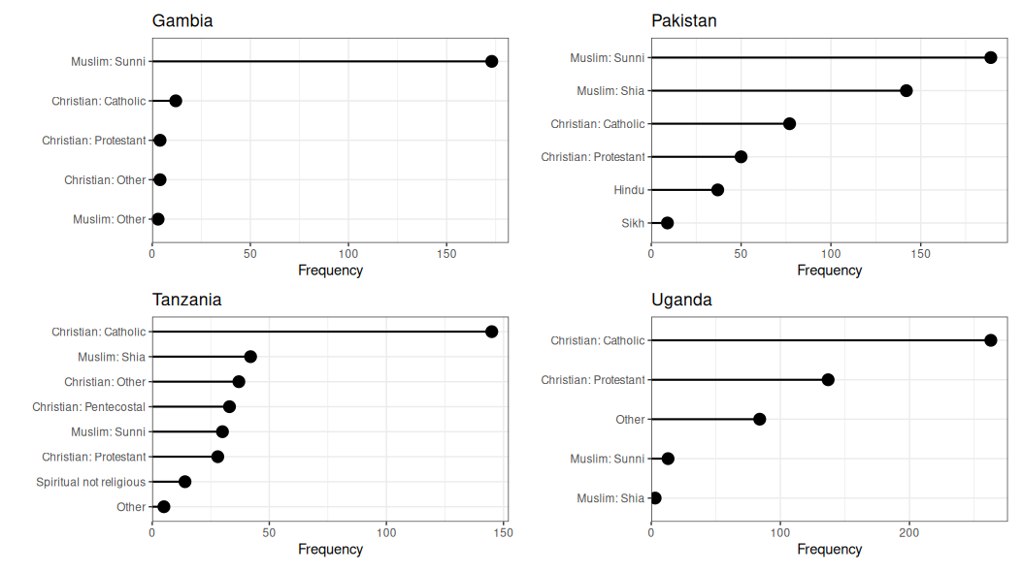

Figure 5. Education Level Distribution by Country

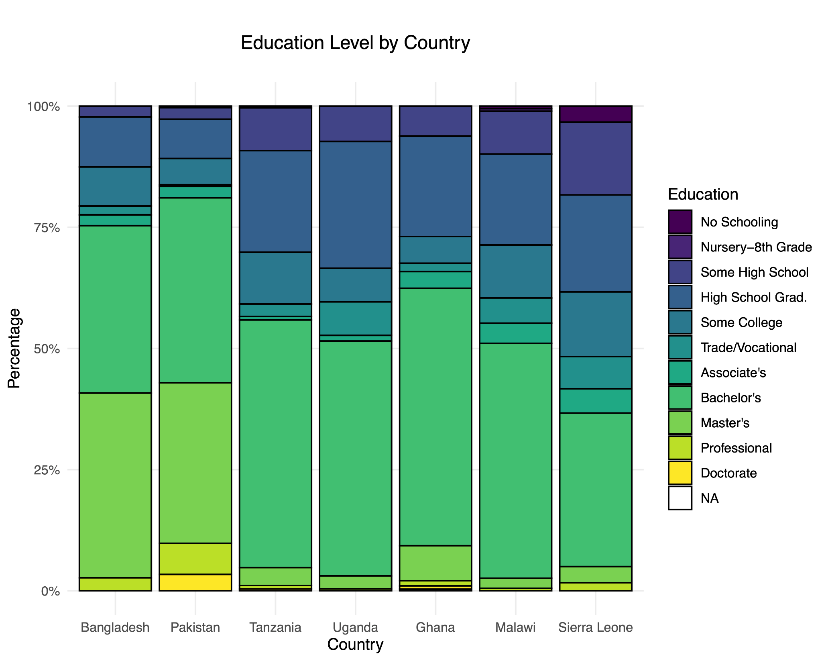

**Measures**

All participants across the four countries completed a standardised survey. They were first provided with information about the survey and asked to complete a consent form. The survey took on average 40 mins to complete, median completion was 37 mins, and the range was 11 - 97 mins. A table summarising the key variables is provided below. Note not all variables collected were analysed for this study but the fill list of items measures is provided in the supplementary material.

Table 2. Key Variables in study

|  |  |  |  |  |  |
| --- | --- | --- | --- | --- | --- |
| Variable | Items | Reliability | Mean | Range | SD |
| Barrier Crossing Leadership | 3 | α = .80 | 4.8 | 1-7 | 1.8 |
| Barrier Bound Leadership | 3 | α = .83 | 4.9 | 1-7 | 1.9 |
| Positive Affect | 1 | N/A | 4.7 | 1-7 | 2.3 |
| Negative Affect | 1 | N/A | 3.5 | 1-7 | 2.3 |
| Vivid Recall & Reflection | 5 | α = .89 | 4.8 | 1-7 | 1.7 |
| Perceived Sharedness | 2 | Spearman-Brown = .76 | 4.7 | 1-7 | 1.9 |
| Defining Experience | 2 | Spearman-Brown = .64 | 4.5 | 1-7 | 1.8 |
| Ingroup Fusion | 4 | α = .90 | 4.8 | 1-7 | 1.9 |
| Ingroup Identification | 4 | α = .95 | 5 | 1-7 | 2.0 |
| Outgroup Fusion | 4 | α = .91 | 3.2 | 1-7 | 1.9 |
| Outgroup Identification | 2 | α = .93 | 3.2 | 1-7 | 2.0 |
| Freedom of Religious Belief | 9 | α = .92 | 6.6 | 1-7 | 2.8 |
| Religious Discrimination | 6 | α = .75 | 2.7 | 1-7 | 1.0 |
| Empathetic Concern | 5 | α = .74 | 4.8 | 1-7 | 1.5 |
| Perspective Taking | 4 | α = .86 | 4.8 | 1-7 | 1.7 |

*Demographic Variables.*

Demographic variables collected were age, sex, relative wealth level, annual income, education level, ethnicity, marital status, number of children, religion, and occupation.

*Ingroup & Outgroup Selection.*

Respondents received an introduction that stated “All people have communities and groups they belong to (ingroups) and those that they do not belong to (outgroups). Examples could include political groups, ethnic groups, or religious groups. Often different groups have different interests and these can be in conflict.” They were then asked, “In your society, (excluding your family) what are three groups that you belong to, that you consider very important to who you are?” and to identify three corresponding outgroups, after being provided with an example of ingroup-outgroup pairs. They were then asked to select one matched pair from the list of three that was most important to them; this was then used as their ingroup and outgroup labels in subsequent questions. As illustrated in Figure 6, the most common group identity selected was religious (49%), with the second most common being professional or academic (16%), followed by social or community based (9%).

Figure 6. Categories of Ingroups selected by Respondents.

*Endorsement of Barrier Crossing & Barrier Bound Leadership.*

To measure endorsement of Barrier Crossing Leadership (BCL) and Barrier Bound Leadership (BBL) we created a novel six-item measure with three items describing BCL and three BBL traits. Responses were measured on a 7-point response scale (see Table 3).

Table 3. Barrier Crossing and Barrier Bound leadership novel items

|  |  |  |  |
| --- | --- | --- | --- |
| Item | Wording | Targeted Trait | Scale |
| Intro | *To what extent do you agree with the following statements? Good leaders should:*  (1- Strongly Disagree to 7- Strongly Agree) |  |  |
| 1 | Seek out opportunities to bridge social divisions with their opponents, enemies, opposition groups, or other relevant outgroups. | Bridging Social Divisions | BCL |
| 2 | Demonstrate willingness to compromise with their opponents, enemies, opposition groups, or other relevant outgroups. | Compromise with Outgroup | BCL |
| 3 | Try to understand and empathize with their opponents, enemies, opposition groups, or other relevant outgroups. | Outgroup Empathy | BCL |
| 4 | Try to accurately represent the interests of the communities and groups that they belong to. | Ingroup Representation | BBL |
| 5 | Seek out opportunities to build stronger connections with the communities and groups they belong to. | Ingroup Connections | BBL |
| 6 | Promote the interests of the communities and groups they belong to even at the expense of other competing groups. | Ingroup focus on Zero-sum interactions | BBL |

Using the full sample, a Confirmatory Factor Analysis (CFA) was conducted on the items to compare a one-factor model against a two-factor model. The two-factor model distinguished between Barrier Crossing Leadership (BCL) and Barrier Bound Leadership (BBL), while the one-factor model combined these constructs into a single factor. The Chi-Square Difference Test revealed a significant difference between the models (*χ*²(1) = 94.293, p < .001), indicating that the two-factor model exhibited a superior fit (CFI = .994, TLI = .988, RMSEA = .051) compared to the one-factor model. Factor loadings for all items were significant (p < .001), with values ranging from 0.694 to 1.046, indicating a strong relationship between the items and their respective constructs. There were no significant cross-loadings, underscoring the distinctness of the two constructs. The raw correlation between the composite scores of BCL and BBL was found to be *r* = .76 (p < .001), affirming a strong positive relationship. Collectively, these findings support the theoretical presumption that while BCL and BBL are related, they represent distinct constructs, thereby validating their separate operationalization in our analyses.

In order to validate the cross-cultural generalizability of the Barrier Crossing Leadership (BCL) and Barrier Bound Leadership (BBL) constructs, a multi-group confirmatory factor analysis was conducted across different country groups. The chi-squared difference test between the unconstrained and constrained models yielded a p-value of .24, indicating a lack of significant discrepancy in the factor structures across countries. This evidence of measurement invariance suggests that the constructs of BCL and BBL are perceived similarly across different cultural contexts, thereby supporting the cross-cultural validity of this construct.

*Important Ingroup Event Description.*

We provided respondents with a general prompt to get them to think about an experience they had that was relevant to their selected ingroup and they felt had a significant impact on them. We wanted to collect a variety of experiences and thus avoided more limiting specifications beyond asking about people’s ‘feelings’ regarding the event. The prompt used was as follows:

*“We want you now to think about <your ingroup> and in particular to try and recall an important experience you have had with <your ingroup>. This should be an experience that had a significant impact on you. Please use the space below and spend 2-3 minutes to describe the event that you are thinking about and tell us how you felt during the experience.”*

The survey included a matched prompt for outgroup experiences, which was seen by 1125 respondents, however, we found that the majority of these had indicated there was no relevant experience to share, provided irrelevant accounts, or misunderstood the question, so we did not analyse this data or the follow-up items asking them to rate the experience.

*Ratings of Ingroup Event.*

To explore the nature of the events selected and responses to them we collected 12 items that sought to measure the following attributes of the experience: positive affect, negative affect, flash-bulb-like recall, perception of shared experience, personal defining-ness, self-reflection, and group defining-ness. Aside from the affect measures which were single-item measures, all other constructs were measured with two items.

Table 4. Variables measuring response to Ingroup Event

|  |  |  |
| --- | --- | --- |
| Item | Wording | Targeted Component |
| Intro | *Continue thinking about the experience you described above. To what extent do you agree with the following statements?*  (1- Strongly Disagree to 7- Strongly Agree) | *N/A* |
| 1 | This experience overall was unpleasant and challenging. | Negative Affect |
| 2 | This experience overall was pleasant and enjoyable. | Positive Affect |
| 3 | My memory of this experience is vivid and detailed. | Flashbulb-like Recall |
| 4 | I can remember clearly who I was with during this experience. | Flashbulb-like Recall |
| 5 | I feel that this experience similarly affected others in my ingroup. | Shared Perception |
| 6 | I feel that this experience is remembered similarly by others in my ingroup. | Shared Perception |
| 7 | This experience was significant for me personally. | Personally Defining |
| 8 | Without this experience I would not be the person I am today. | Personally Defining |
| 9 | I have spent a lot of time reflecting on the experience I described. | Self-reflection |
| 10 | I think about this experience a lot more than other experiences in my life. | Self-reflection |
| 11 | This experience is very important to the ingroup. | Group defining-ness |
| 12 | Without this experience, the ingroup would not be what it is today. | Group defining-ness |

As these items were derived from measures used in previous studies exploring imagistic experiences, we conducted a CFA to assess whether the anticipated five-factor structure was observed in the dataset. The CFA did provide some support for the five-factor model on several fit indices but there were indications that a simpler model might be a better fit for the data so we explored alternative factor structures using EFA. A recurrent issue that emerged was the equivalent cross-loading of item 11 across factors so it was dropped from analyses.

From EFA analyses conducted with the remaining 10 items, a three factor structure emerged as the best fit and most coherent structuring of the variables. The three factors were labeled as indicators of 1) Vivid, 2) Perceived Sharedness, and 3) Defining Experience. The defining experience was constructed from one personal and one group defining items that asked about how essential the experience was to the personal and group identity.

The Vivid Recall & Reflection factor was comprised of both self reflection items, both flashbulb like recall items, and the personal defining item that asked about significance of the experience. This factor collectively accounted for approximately 33% of the total variance in the measured constructs. Perceived Sharedness meanwhile contributed to around 17% of the total variance, while Defining Experience explained an additional 14%. The factors displayed moderate intercorrelations, with Vivid Recall & Reflection exhibiting moderate associations with both Perceived Sharedness (*r* = .70) and Defining Experience (*r* = .72), while Perceived Sharedness and Defining Experience demonstrated a moderate correlation of 0.66.

The model fit indices provided robust support for the adequacy of the three-factor model. The Tucker-Lewis Index (TLI) reached an excellent fit level at .998, while the Root Mean Square Error of Approximation (RMSEA) indicated a reasonable fit with a value of .038 and a 90% confidence interval ranging from .025 to .051. Additionally, the empirical chi-square test produced a highly significant result, reinforcing the model's appropriateness for representing the data. The cumulative proportion of variance explained by the three factors amounted to 60%. Cronbach’s alphas were high for the vivid recall & reflection and perceived sharedness measures and moderately weak for the defining experience measure.

Table 5. Standardized Loadings from Three Factor EFA

|  |  |  |  |
| --- | --- | --- | --- |
| Item | Vivid Recall & Reflection | Perceived Sharedness | Defining Experience |
| Reflection 1 | .50 | .11 | .22 |
| Reflection 2 | .44 | .01 | .35 |
| Personal Defining 1 | .67 | .02 | .15 |
| Personal Defining 2 | .26 | -.13 | .62 |
| Perceived Share 1 | .19 | .56 | .06 |
| Perceived Share 2 | .22 | .63 | .01 |
| FB Memory 1 | .82 | .13 | -.08 |
| FB Memory 2 | .75 | .15 | -.06 |
| Group Defining 2 | -.19 | .31 | .59 |
|  |  |  |  |
| Eigenvalue | 12.25 | 5.49 | 5.34 |
| % of variance | 32 | 14 | 14 |
| Reliability | α = .89 | S-B = .76 | S-B = .64 |

*Identity Fusion and Group Identification.*

We collected identity fusion and group identification using two shortened four-item scales, replicating the items used in an earlier study on Barrier Crossing Leadership [(Buhrmester et al., 2022)](https://www.zotero.org/google-docs/?MPButc). The fusion items are taken from the verbal fusion scale [(Gómez et al., 2011)](https://www.zotero.org/google-docs/?iYBEEn) and the group identification items are from the single-item social identification measure [(Postmes et al., 2013)](https://www.zotero.org/google-docs/?0Xx3Nx) and the group identification scale devised by [Leach et al. (2008)](https://www.zotero.org/google-docs/?pTQyiA). All eight items were collected for both an ingroup and outgroup target that had been nominated as most salient by the respondent. We conducted a CFA to ensure that the constructs could be distinguished in the data and found support for this. Full details are available in the supplementary material. For the ingroup Fusion scale, the Cronbach's Alpha was 0.90 and for the Group Identification scale exhibited an even higher level of internal consistency with a Cronbach's Alpha of .95.

Table 6. Fusion and Identification measures

|  |  |  |  |
| --- | --- | --- | --- |
| Item | Wording | Component | Scale |
| Intro | *To what extent do you agree with the following statements in regard to your ingroup:*  (1- Strongly Disagree to 7- Strongly Agree) | *N/A* | N/A |
| 1 | I have a deep emotional bond with the [ingroup]. | Fusion | Verb. Fusion |
| 2 | I am strong because of the [ingroup]. | Fusion | Verb. Fusion |
| 3 | I make the [ingroup] strong. | Fusion | Verb. Fusion |
| 4 | I am one with the [ingroup]. | Fusion | Verb. Fusion |
| 5 | I identify with the [ingroup]. | Identification | SISI |
| 6 | I have a lot in common with the [ingroup]. | Identification | Group Idt. |
| 7 | I connect with the values of the [ingroup]. | Identification | Group Idt. |
| 8 | I feel a sense of belonging with the [ingroup]. | Identification | Group Idt. |

*Outgroup Fusion and Group Identification.*

The same eight items used to explore ingroup fusion and identification were also asked in relation to respondents’ selected outgroups. Based on the theoretical models and the structure observed with ingroup measures we conducted a Confirmatory Factor Analysis (CFA) with the fusion and identification items specified as latent factors. The results indicated that the two-factor model was a reasonable fit, so we adopted this approach to provide comparisons with the ingroup measures. Full details of robustness checks and model comparisons are in the supplementary material.

*Freedom of Religious Belief.*

To measure endorsement of religious freedom we used a 9-item scale from the Social Perception of Religious Freedom- SPRF (Breskaya & Giordan, 2019) that contained items that address endorsement of individual autonomy, freedom to manifest religion, and state obligation to religious freedom. The scale's reliability statistics indicated a high internal consistency with a Cronbach's alpha of .93, with item-level statistics displaying moderate to strong positive correlations with the total score, indicating good item discrimination.

*Religious Discrimination*

We measured experiences of religious discrimination using a reduced 6-item version of the Religious Discrimination Scale (Allen et al., 2018) containing items targeting perceived prejudice, negative labels, and closeted symptoms. We collected the full 11-item scale for 1109 respondents but reduced the scale by five items to reduce survey duration and hence use the six items that all respondents completed in our analysis. The scale's reliability statistics indicated a high internal consistency with a Cronbach's alpha of .75, with item-level statistics with strong positive correlations with the total score, indicating good item discrimination.

*Empathetic Concern*

We used a 5-item version of the empathetic concern subscale from the Interpersonal Reactivity Index (Davis, 1980). The full subscale is 7 items which we collected for 1106 respondents, however, we removed two items to reduce survey time and so report the reduced version completed by all respondents. With recoded reverse items, the scale displayed moderately strong reliability, with a Cronbach’s alpha of 0.74 and item statistics indicating moderate to strong correlations with the total score.

*Perspective Taking.*

We used a 4-item version of the perspective-taking concern subscale of the Interpersonal Reactivity Index (Davis, 1980). Again, we initially included the full 7-item subscale for 1106 respondents but reduced the scale by three items to reduce survey length. The subsequent 4-item scale displayed strong reliability with a Cronbach’s alpha of .85 and item statistics indicating moderate to strong correlations with the total score. The correlation between the perspective-taking and empathetic concern scores was moderate but acceptable for treating them separately (r = .71).

Figure 7. Correlation Matrix of Key Variables

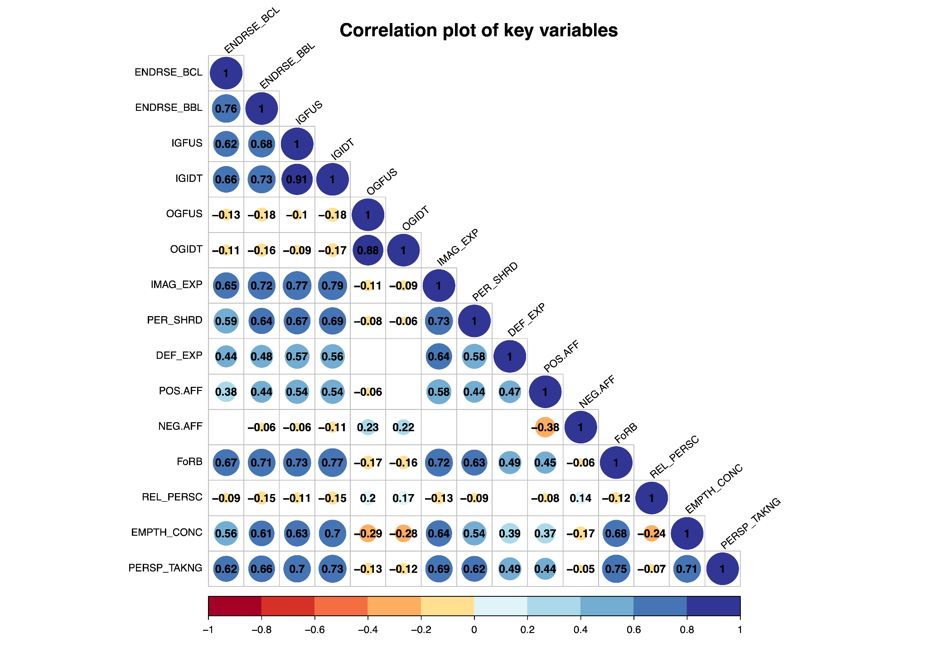

**Results**

**1. Do those who report stronger imagistic ingroup experiences display higher levels of ingroup fusion?**

To explore whether imagistic ingroup experiences displayed a relationship with ingroup fusion with the ingroup, we undertook a stepwise linear mixed-effects modeling strategy (see Table 7), which factored in potential variability between countries as a random effect.

Table 7. Summary of MLM regression models predicting Fusion with ingroup

|  |  |  |  |  |  |
| --- | --- | --- | --- | --- | --- |
| Model | df | AIC | BIC | L.Ratio | p-value |
| 1. Intercept Only | 2 | 6211 | 6222 |  |  |
| 2. + Random Intercept (Country) | 3 | 6210 | 6226 | 3.38 | .07 |
| 3. + Demographic Measures (Excluded) | 8 | 6214 | 6256 | 6.26 | .28 |
| 4. + Affect Measures | 5 | 5634 | 5660 | 580.39 | <.001 |
| 5. + Vivid Recall & Reflection, + Defining Experience, + Perceived Sharedness | 8 | 4638 | 4681 | 1001.20 | <.001 |

Our initial intercept-only model (Model 1) had an AIC of 6211 and a BIC of 6222. Introducing a random intercept for countries (Model 2) marginally improved the model fit (AIC = 6210, BIC = 6226) and, while the improvement in log likelihood was at the edge of significance (L.Ratio = 3.38, p = .07), we retained this random factor due to its theoretical relevance. Incorporating demographic variables into the subsequent model (Model 3) did not lead to a significant enhancement of the model's performance (AIC = 6214, BIC = 6256, L.Ratio = 6.26, p = .282). Hence, we removed them and examined improvement when adding affect measures (Model 4). Here we observed a substantial improvement (AIC = 5634, BIC = 5660, L.Ratio = 580.39, p < .001). The further final addition of measures of vivid recall & reflection, perceived sharedness, and defining experience, (Model 5) led to an even more optimized fit (AIC = 4638, BIC = 4681, L.Ratio = 1001.20, p < .001).

The strongest predictor in the final model was the vivid recall & reflection measure with a β coefficient of .59, p < .001, followed by perceived sharedness at β= .19 , p < .001, and positive affect at β= .10 ,p < .001. Defining experiences also emerged as a significant predictor with a smaller coefficient of β= 0.06, p = .008. Conversely, negative affect did not significantly influence fusion with the ingroup, β= .01, p = .66. Random effects suggested variability in fusion scores across countries with a standard deviation of 0.06. The model incorporated data from 1523 participants distributed over 7 countries and the correlation coefficients are shown in Figure 8 below.

Figure 8. Predictors of Fusion with Ingroup

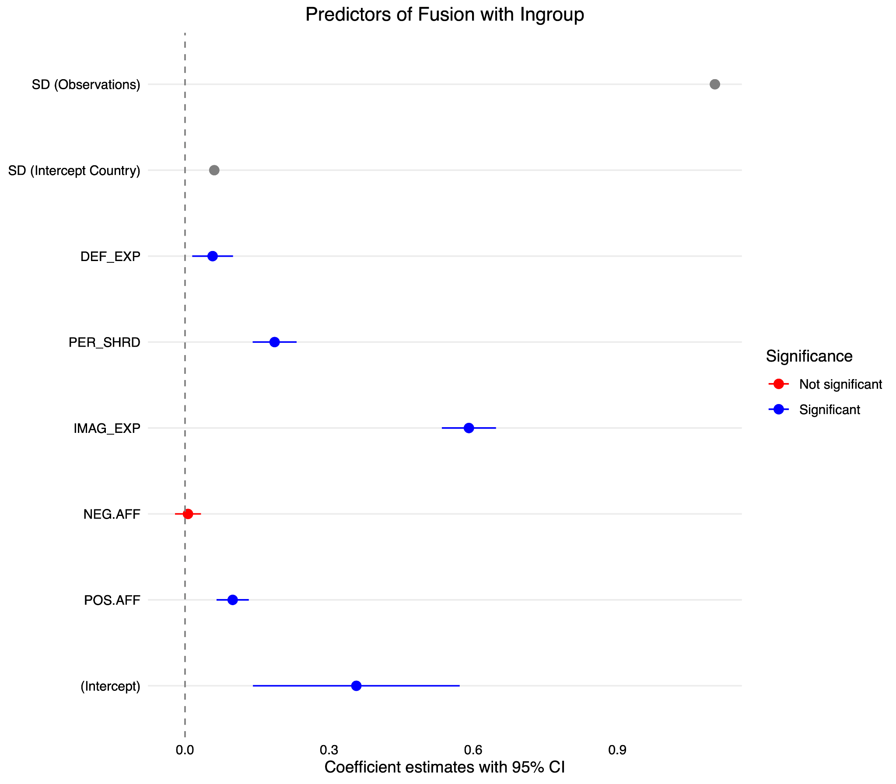

For robustness checks, we also examined the same stepwise linear mixed-effects models with ingroup identification as the outcome.

Table 8.Summary of MLM regression models predicting identification with ingroup

|  |  |  |  |  |  |
| --- | --- | --- | --- | --- | --- |
| Model | df | AIC | BIC | L.Ratio | p-value |
| 1. Intercept Only | 2 | 6398 | 6409 |  |  |
| 2. + Random Intercept (Country) | 3 | 6388 | 6404 | 12.20 | <.001 |
| 3. + Demographic Measures (Excluded) | 8 | 6388 | 6431 | 9.46 | = .09 |
| 4. + Affect Measures | 5 | 5827 | 5853 | 565.21 | <.001 |
| 5. + Vivid Recall & Reflection, + Defining Experience, + Perceived Sharedness | 8 | 4682 | 4724 | 1151.03 | <.001 |

Our initial intercept-only model (Model 1) had an AIC of 6398 and a BIC of 6409. Introducing a random intercept for countries (Model 2) significantly improved the model fit (AIC = 6388, BIC = 6404) with a notable improvement in log-likelihood (L.Ratio = 12.20, p < .001). Incorporating demographic variables into the subsequent model (Model 3) again did not significantly enhance the model's performance (AIC = 6388, BIC = 6431, L.Ratio = 9.46, p = .09). Hence, we removed them and examined improvement when adding affect measures (Model 4). As before, we observed a substantial improvement (AIC = 5827, BIC = 5853, L.Ratio = 565.21, p < .001). The last additions of measures of vivid recall & reflection, perceived sharedness, and defining experience, (Model 5) again led to a more optimized fit (AIC = 4682, BIC = 4724, L.Ratio = 1151.03, p < .0001).

Similar to the fusion outcome, the strongest predictor in the final model was the vivid recall & reflection measure with a coefficient of β= .68, p < .001, followed by perceived sharedness at β= .23, p < .001, and positive affect at β= .08 , p < .001. Defining experiences in this model was not a significant predictor β= .01 , p = .77. Negative affect displayed a weak negative relationship, β= -.04, p = .005. Random effects suggested negligible variability in identification scores across countries with a very small standard deviation for the intercept. The model incorporated data from 1552 participants distributed over 7 countries and the correlation coefficients are shown in Figure 9 below.

Figure 9. Predictors of identification with Ingroup

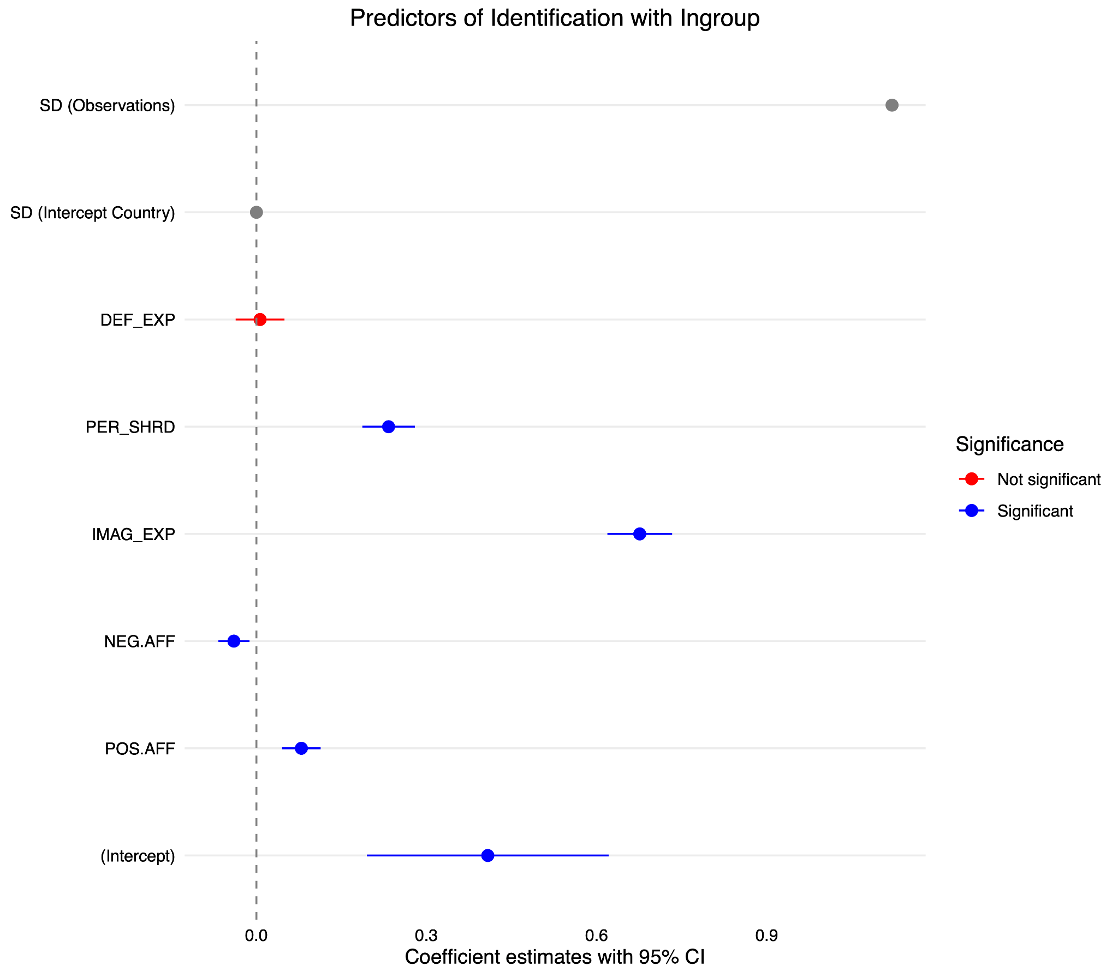

Collectively, these results indicated that controlling for variation between countries, vivid recall & reflection, perceived sharedness, and positive affect were consistent predictors of both fusion and identification measures, with the vivid recall & reflection measure the strongest predictor in both models. The defining experience measure was however only predictive of fusion. We confirmed this by regressing ingroup fusion on ingroup identification and calculating the residuals to produce a new variable representing the portion of variance in the fusion measure that was independent from identification [(see Kavanagh et al., 2019)](https://www.zotero.org/google-docs/?83M3S4).

Using this as the outcome variable with all the previous predictors from previous models, including demographic controls, we found a reasonable fit model with AIC and BIC values of 3299 and 3368 respectively. Among the predictors, there were significant but weak relationships observed with positive affect (β = .04, p =.005) and negative affect (β = .04, p < .001). As anticipated, there was a weak positive relationship with the defining experience measure (β = .05, p < .001) and no significant relationships found with the vivid recall & reflection experience (p = .64) and perceived sharedness measures (p= .35). The model contained data from 1522 observations across 7 countries.

These findings accord with previous research on identity fusion and demonstrate a potentially unique relationship with defining experiences. They also illustrates the importance of examining matched identification measures before claiming that observed relationships are unique to the construct.

**2. Do those who report imagistic outgroup experiences display stronger endorsement of barrier crossing approaches to leadership?**

1125 respondents were presented with a prompt asking them to try and recall an important experience, they had with their outgroup that had a significant impact on them and 1063 provided some response. However, in reviewing these responses we found that there was a large number of responses that were low quality, provided irrelevant accounts, or indicated that they did not have a relevant experience. This issue was why the section of the survey was selected to be removed for N= 469 to reduce the survey length. A CFA using the anticipated structure from the matched ingroup measures displayed poor fit indices, subsequent exploratory factor analyses did identify three factors with the most coherent being the two perceived sharedness loading highly together. Due to concerns about data quality and weak factor structure we conducted a simple correlation analysis of scores on the reflection, perceived sharedness, and defining experience measures, with endorsement of barrier-crossing and barrier bound leadership and outgroup fusion and identification.

We found significant positive relationships with all imagistic experience variables and endorsement of barrier-crossing leadership, with the strongest correlation observed with perceived sharedness (*r* = .37, p <.001). However, as shown in Figure 10 all of these relationships were also observed for endorsement of barrier bound leadership as well. A weak positive correlation was also observed for negative affect ratings, but no such score was observed with positive affect scores. Focusing on outgroup fusion and identification, we found positive correlations with all three imagistic variables, although the association with perceived sharedness was weak (*r* = 0.1, p < .001). In line with previous findings, positive affect was strongly associated with both outgroup fusion and identification (both *r* =.52, p < .001), while negative affect scores displayed a negative relationship.

In summary, although we found very few accounts that fit the ideal template of an imagistic outgroup experience and our reservations about data quality, we did observe the anticipated positive relationships with imagistic experience variable ratings.

Figure 10. Correlation plot of outgroup experience variables.

**3. Do levels of ingroup or outgroup fusion predict endorsement of Barrier Crossing approaches to leadership?**

We conducted a series of linear mixed-effects models to identify the variables best predicting endorsement of barrier crossing leadership anticipating that both ingroup and outgroup fusion would be predictive factors. However, we built our models sequentially to provide a robust test of these relationships.

Consequently, a series of hierarchical linear mixed-effects models were fitted to predict endorsement of barrier crossing leadership. Starting with a basic model only containing an intercept (Model 1), models progressively incorporated potential contributing variables such as country modelled as a random effect (Model 2), demographic factors (Model 3), alternative predictors including empathetic concern and perspective-taking (Model 4), then ingroup fusion and identification measures (Model 5), and finally outgroup fusion and identification measures. An ANOVA comparison of these models showed that each additional model provided a significant improvement in fit over its predecessor, with the most notable improvements when adding empathy and perspective-taking to the model (Model 4) and when integrating fusion and identity measures (Model 5). The final model (Model 6) which added outgroup fusion and identification saw no improvement and so Model 5 was adopted as the best fitting model among the compared set with the lowest AIC (4905) and BIC (4968) values.

Table 9.Summary of MLM regression models predicting Barrier Crossing Leadership

|  |  |  |  |  |  |
| --- | --- | --- | --- | --- | --- |
| Model | df | AIC | BIC | L.Ratio | p-value |
| 1. Intercept Only | 2 | 5860 | 5871 |  |  |
| 2. + Random Intercept (Country) | 3 | 5844 | 5860 | 17.53 | <.001 |
| 3. + Demographic Measures | 8 | 5841 | 5883 | 9.46 | = .02 |
| 4. + Empathetic Concern + Perspective Taking | 10 | 5021 | 5074 | 824.32 | <.001 |
| 5. + Ingroup Fusion + Identification | 12 | 4905 | 4968 | 119.98 | <.001 |
| 6. + Outgroup Fusion + Identification | 14 | 4908 | 4982 | 0.43 | = .81 |

In examining the predictors for Endorsement of barrier-crossing leadership based on Model 5, the linear mixed-effects model revealed significant variance across countries, as indicated by the random effect of country (SD = .04). The model, fitted via maximum likelihood, displayed an AIC and BIC of 4905 and 4968 respectively, with a log-likelihood of -2440.57.

With regard to the fixed effects, several predictors emerged as statistically significant. Amongst demographics, age (β = .00, p = 0.99), female-sex (β = .11, p = .10), and wealth (β = .00, p = .41) were not significant. Other-sex (β = -.73, p = .03) and education level (β = -.03, p = .06) displayed a relationship. The strongest predictors were ingroup identification (β = .31, p < .001) and perspective taking (β = .28, p < .001) and a weaker relationship was also observed with empathetic concern (β = .10, p = .006). Ingroup fusion did not significantly contribute (β = .05, p = .27). The model was based on a total of 1482 observations across 7 countries.

This result was counter to our expectations as no relationship was found with ingroup fusion or outgroup fusion when controlling for group identification. Notably, in a model with demographic and empathy variables included but no identification variables, ingroup fusion did display the anticipated positive relationship (β = .31, p < .001) although no such relationship was found for outgroup fusion (β = -.01, p = .46). This illustrates the importance of including matched identification measures, and the consistent relationship observed with empathetic variables (as both empathetic concern and perspective taking maintained robust relationships in all models).

To better understand the observed relationships we also conducted the same series of hierarchical linear mixed-effects models to predict endorsement of Barrier Bound Leadership. As before, the models displayed progressively better fit with the additional of related variables. However, unlike with Barrier Crossling Leadership the addition of demographic variables did not improve the model (Model 2). They were retained in order to keep the analyses consistent with those used for Barrier Crossing Leadership. The final model adding outgroup fusion and identification again showed no improvement and were removed so the coefficients reported below are from Model 5.

Table 10.Summary of MLM regression models predicting Barrier Bound Leadership

|  |  |  |  |  |  |
| --- | --- | --- | --- | --- | --- |
| Model | df | AIC | BIC | L.Ratio | p-value |
| 1. Intercept Only | 2 | 5958 | 5969 |  |  |
| 2. + Random Intercept (Country) | 3 | 5927 | 5943 | 32.74 | <.0001 |
| 3. + Demographic Measures | 8 | 5928 | 5970 | 9.14 | = .10 |
| 4. + Empathetic Concern + Perspective Taking | 10 | 4978 | 5031 | 954.02 | <.0001 |
| 5. + Ingroup Fusion + Identification | 12 | 4685 | 4748 | 297.33 | <.0001 |
| 6. + Outgroup Fusion + Identification | 14 | 4687 | 4761 | 1.42 | = .49 |

In examining the predictors for endorsement of Barrier Crossing Leadership based on the linear mixed-effects model, the model revealed significant variance across countries, as indicated by the random effect of country (SD = .13). The model, fitted via maximum likelihood, displayed an AIC and BIC of 4685 and 4748 respectively, with a log-likelihood of -2330.62.

With regard to the fixed effects, several predictors emerged as statistically significant. Amongst demographics, age (p = .96), female gender (p = .72), and wealth (p = .95) were not significant. Other gender (β = -.66, p = .04) and Education_ranked (β = -.035, p = .03) displayed a relationship. The strongest positive predictors were ingroup identification (β = .42, p < .001) and perspective taking (β = .26, p < .001), while a relationship was also observed with empathetic concern (β = .12, p < .001). Ingroup fusion again did not significantly contribute (β = .04, p = .37). The model was based on a total of 1472 observations across 7 countries.

These results indicate that the same relationships were observed for both barrier crossing leadership and barrier bound leadership, which was unexpected theoretically but not unexpected given the high correlation observed in the data between the two measures (r = .76). See Figure 11 for a presentation of relevant coefficients in matched models.

Figure 11. Predictors of endorsement of Barrier Bound and Barrier Crossing Leadership

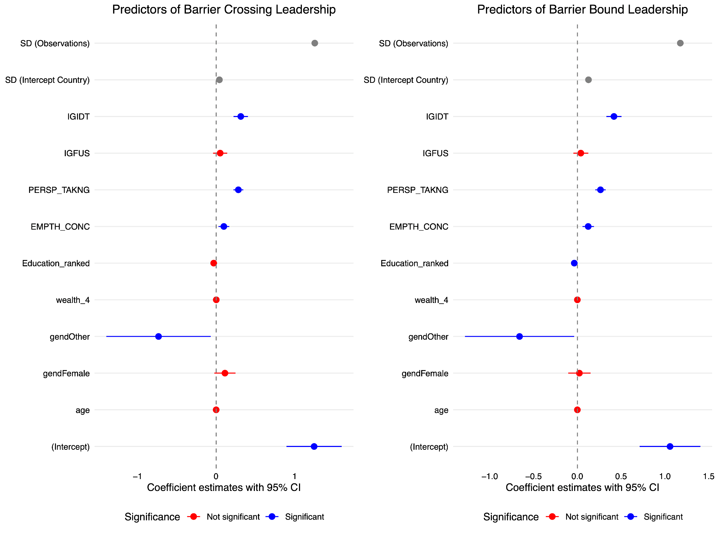

We also conducted an exploratory analysis to examine the roles of ingroup fusion and identification in mediating the relationship between imagistic experiences and endorsement of barrier trossing leadership. A parallel mediation model was applied to a dataset of 1,482 participants. The model outcomes found significant mediating roles of both constructs in the mentioned relationship. However, the pathways exhibited differing strengths. Specifically, the standardized indirect effect through fusion was only -.02 (Estimate = -.02, p = .53), suggesting a negligible mediating role for fusion. In contrast, the pathway through identification was considerably stronger, with a standardized indirect effect of 0.30 (Estimate = .31, p < 0.001). When considering the total indirect effect of both mediators combined, approximately 28.8% of the relationship between imagistic experiences and endorsement of barrier crossing leadership was captured by these pathways, while the direct effect accounted for around 36.8% of this relationship. Collectively, these results underscore the salient mediating role of identification, as opposed to fusion, in understanding the connection between imagistic experiences and leadership endorsement tendencies.

**4. How do imagistic experiences, support for barrier-crossing leadership, and differing types of group alignment relate to support for Freedom of Religious Belief?**

To examine the relationships between relevant predictor variables and support for Freedom of Religious Belief we first constructed an intercept only model and then compared this with a model adding a random effect for Country and religion. The model showed no improvement with these random effects added and so they were excluded and a series of standard linear regression models were conducted instead.

The addition of demographic factors (Model 2) indicated no substantial improvement in the model fit metrics, but as the improvement fell close to conventional thresholds the items were retained for robustness. Adding empathetic variables substantially improved the model (Model 4) but no improvement was observed when adding religious discrimination (Model 5) so this was removed. Adding ingroup fusion and identification significantly improved the model (Model 6) but no such improvement was observed with matched outgroup fusion and identification measures (Model 7). Finally, we added all the imagistic and affect measures related to the ingroup experience the respondent described (Model 8). This final model provided the best fit overall and was the most comprehensive. The details of this final model are provided below.

Table 11. Summary of regression models predicting Freedom of Religious Belief

|  |  |  |  |  |  |
| --- | --- | --- | --- | --- | --- |
| Model | df | AIC | BIC | L.Ratio | p-value |
| 1. Intercept Only | 2 | 7189 | 7199 |  |  |
| 2a. + Random Intercept (Country) (Removed) | 3 | 7189 | 7205 | 2.02 | = .16 |
| 2b. + Random Intercept (Religion) (Removed) | 3 | 7191 | 7207 | 0.07 | = .80 |
| 3. + Demographic Measures | 7 | 7189 | 7226 | 9.65 | = .09 |
| 4. + Empathetic Concern + Perspective Taking | 9 | 5830 | 5878 | 1363.17 | < .001 |
| 5. + Religious Discrimination (Removed) | 10 | 5832 | 5885 | 0.53 | = .46 |
| 6. + Ingroup Fusion + Identification | 11 | 5515 | 5574 | 318.32 | < .001 |
| 7. + Outgroup Fusion + Identification (Removed) | 13 | 5517 | 5586 | 2.48 | = .29 |
| 8. + Vivid Recall & Reflection + Defining Experience, + Perceived Sharedness + Affect Measures | 16 | 5462 | 5547 | 60.82 | < .001 |

Examining the final model for endorsement of freedom of religious belief (FoRB), the model was able to account for a substantial proportion of the variance in FoRB, with a substantial R2 of 69.47%. The model's overall fit was statistically significant, with an F(14, 1464) = 238, p < .001.

Key predictors that showed strong standardized contributions to the model include Perspective Taking (β = .26, p < .001), Ingroup Identification (β = .27, p < .001), Vivid Recall & Reflection (β = .18, p < .001), and Empathetic Concern (β = .15, p < .001). Amongst demographic factors only education displayed a significant but weak negative relationship β= -0.05, p = 0.001. Notably, ingroup fusion did not contribute significantly to the model. Nor did positive or negative affect, defining experience, or perceived sharedness. The relative contributions of variables to the model are presented below in Figure 11.

Notably, when run without identification measures included fusion with ingroup was the strongest predictor in Model 6 (β = .36, p < .001) and with the addition of all imagistic experience variables in Model 8, however the size of the relationship was reduced in this model (β = .23, p < .001). To further examine these relationships, we examined the potential mediating roles of ingroup fusion and identification in the relationship between vivid recall & reflection and endorsement of Freedom of Religious Belief. Our findings, based on data from 1,479 participants, suggest that both act as significant mediators in this relationship.

In examining first, the mediating role of ingroup fusion in the relationship between vivid recall and reflection, a key component of imagistic experiences, and endorsement of freedom of religious belief, our analysis revealed significant direct and indirect effects. The direct effect of vivid recall and reflection on endorsement of freedom of religious belief was significant (c = 0.68, p < .001, SE = 0.04). Additionally, vivid recall and reflection significantly predicted ingroup fusion (a = 0.85, p < .001, SE = 0.02), and in turn, ingroup fusion significantly predicted endorsement of freedom of religious belief (b = 0.60, p < .001, SE = 0.04). The indirect effect, which quantifies the mediation role of ingroup fusion, was also significant (indirect effect = 0.51, p < .001, SE = 0.04). This suggests that vivid recall and reflection not only influences endorsement of freedom of religious belief directly but also indirectly via its impact on ingroup fusion.

Given the relationships observed with identification we also explored a parallel mediation analysis involving both ingroup fusion and identification as mediators in the relationship between vivid recall and reflection and endorsement of freedom of religious belief. Here we found that in addition to the relationship observed with ingroup fusion (a1 = 0.85, p < 0.001), there was also a robust relationship with identification (a2 = 0.93, p < 0.001). Crucially, with both mediators in the model ingroup fusion now displayed only a marginally significant relationship with FoRB (b1 = 0.07, p = 0.051), whereas identification had a strong and significant relationship (b2 = 0.66, p < 0.001). The indirect effect through ingroup fusion was marginally significant (indirect1 = 0.06, p = 0.051), suggesting a possible mediation. However, the indirect effect through identification was substantial and highly significant (indirect2 = 0.61, p < 0.001), indicating a strong mediation. The total effect, accounting for both mediators, remained significant (total = 1.19, p < 0.001).

In summary, while both fusion and identification mediated the relationship between vivid recall and reflection and endorsement of freedom of religious belief, identification emerged as the more potent mediator. This was confirmed by a contrast analysis which found the contrast between the two indirect effects to be -0.55 and highly significant (p < 0.001). When considering the total indirect effect of both mediators combined, 41.9% of the relationship is accounted for by the indirect pathways, while the direct effect 32%.

Figure 12. Predictors of Support for Freedom of Religious Belief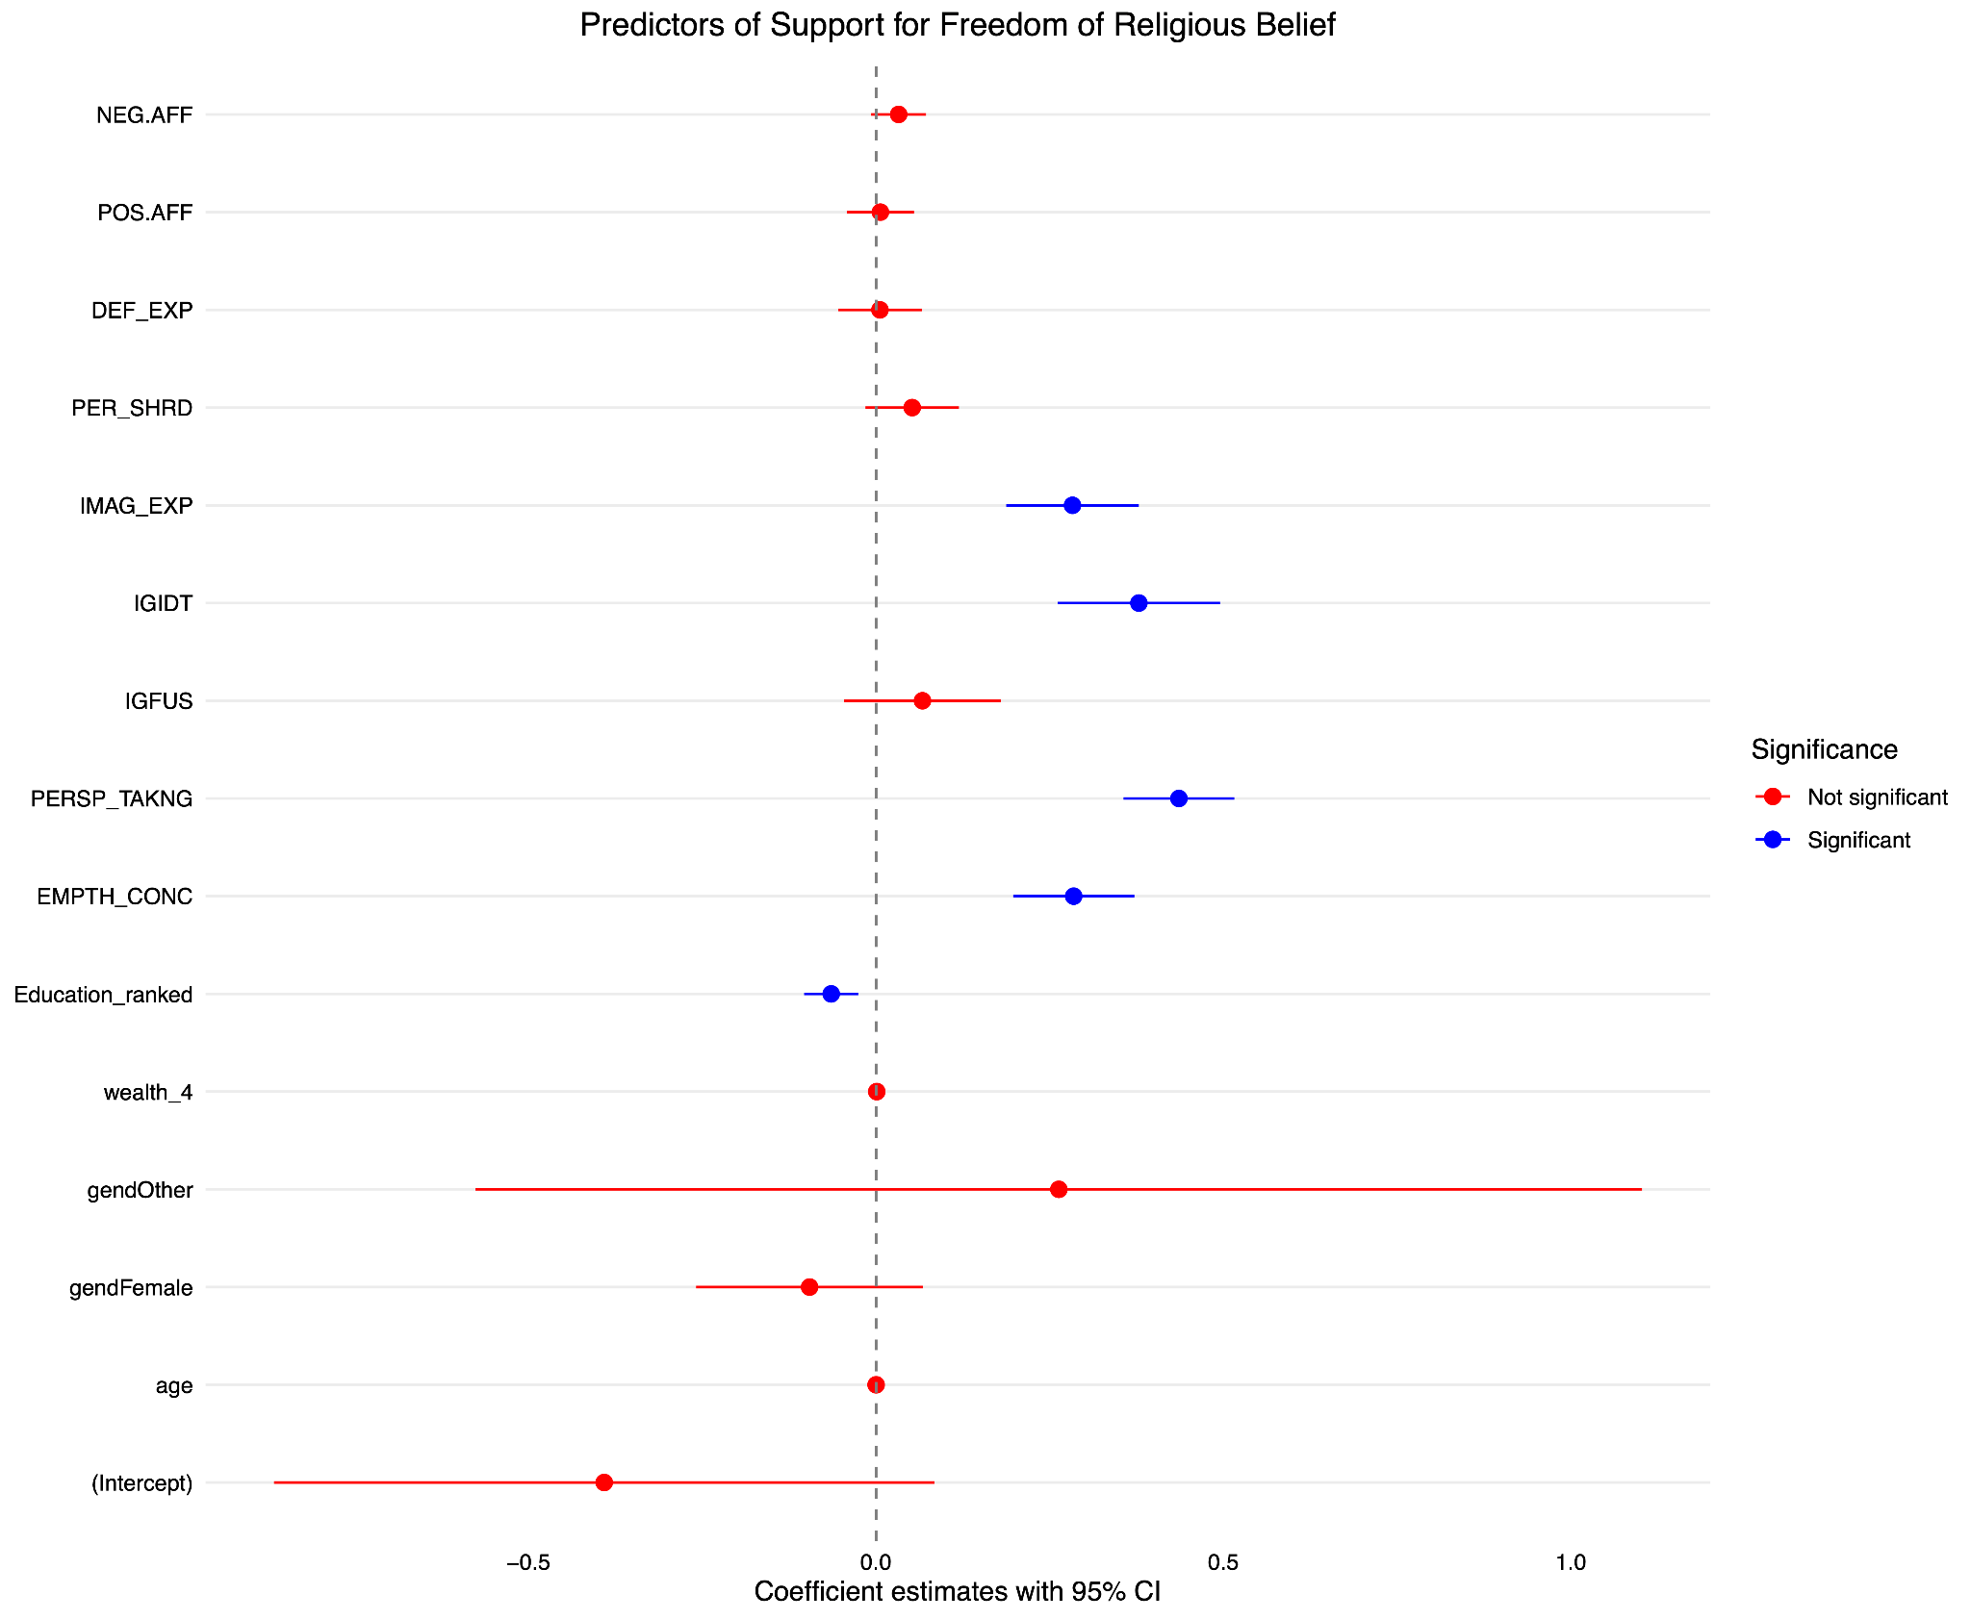

**Discussion**

**Conclusion**

In summary,

**Limitations**

There are a number of significant limitations with our current study

References

[Berntsen, D., & Rubin, D. C. (2006). The centrality of event scale: A measure of integrating a trauma into one’s identity and its relation to post-traumatic stress disorder symptoms. *Behaviour Research and Therapy*, *44*(2), 219–231.](https://www.zotero.org/google-docs/?b42fHX)

[Buhrmester, M. D., Cowan, M. A., & Whitehouse, H. (2022). What Motivates Barrier-Crossing Leadership? *New England Journal of Public Policy*, *34*(2), 7.](https://www.zotero.org/google-docs/?b42fHX)

[Bulbulia, J. A., Geertz, A. W., Atkinson, Q. D., Cohen, E., Evans, N., Francois, P., Gintis, H., Gray, R. D., Henrich, J., Jordan, F. M., Norenzayan, A., Richerson, P. J., Slingerland, E., Turchin, P., Whitehouse, H., Widlok, T., & Wilson, D. S. (2013). The Cultural Evolution of Religion. In P. J. Richerson & M. H. Christiansen (Eds.), *Cultural Evolution: Science, Technology, Language, and Religion.* (pp. 381–404). MIT Press.](https://www.zotero.org/google-docs/?b42fHX)

[Decety, J., & Cowell, J. M. (2014a). Friends or Foes: Is Empathy Necessary for Moral Behavior? *Perspectives on Psychological Science*, *9*(5), 525–537. https://doi.org/10.1177/1745691614545130](https://www.zotero.org/google-docs/?b42fHX)

[Decety, J., & Cowell, J. M. (2014b). The complex relation between morality and empathy. *Trends in Cognitive Sciences*, *18*(7), 337–339.](https://www.zotero.org/google-docs/?b42fHX)

[Decety, J., & Cowell, J. M. (2015). Empathy, Justice, and Moral Behavior. *AJOB Neuroscience*, *6*(3), 3–14. https://doi.org/10.1080/21507740.2015.1047055](https://www.zotero.org/google-docs/?b42fHX)

[Durkheim, E. (1965). *The Elementary forms of the religious life.* (J. M. Ward, Trans.). Free Press.](https://www.zotero.org/google-docs/?b42fHX)

[Fischer, R., Callander, R., Reddish, P., & Bulbulia, J. A. (2013). How do rituals affect cooperation? An experimental field study comparing nine ritual types. *Human Nature (Hawthorne, N.Y.)*, *24*(2), 115–125. https://doi.org/10.1007/s12110-013-9167-y](https://www.zotero.org/google-docs/?b42fHX)

[Fischer, R., Xygalatas, D., Mitkidis, P., Reddish, P., Tok, P., Konvalinka, I., & Bulbulia, J. A. (2014). The fire-walker’s high: Affect and physiological responses in an extreme collective ritual. *PloS One*, *9*(2), e88355. https://doi.org/10.1371/journal.pone.0088355](https://www.zotero.org/google-docs/?b42fHX)

[Foxeus, N. (2019). The Buddha was a devoted nationalist: Buddhist nationalism, *ressentiment* , and defending Buddhism in Myanmar. *Religion*, *49*(4), 661–690. https://doi.org/10.1080/0048721X.2019.1610810](https://www.zotero.org/google-docs/?b42fHX)

[Froerer, P. (2007). *Religious division and social conflict: The emergence of Hindu nationalism in rural India*. Berghahn Books. https://books.google.com/books?hl=en&lr=&id=G7u45eiQ4MAC&oi=fnd&pg=PR9&dq=s+hindu+nationalism+religious+division&ots=ybFRgpRlEV&sig=RzxzOYg1lKRo3V7j_AK9kPchxng](https://www.zotero.org/google-docs/?b42fHX)

[Gómez, A., Brooks, M. L., Buhrmester, M. D., Vázquez, A., Jetten, J., & Swann, W. B. (2011). On the nature of identity fusion: Insights into the construct and a new measure. *Journal of Personality and Social Psychology*, *100*(5), 918–933. https://doi.org/10.1037/a0022642](https://www.zotero.org/google-docs/?b42fHX)

[Gómez, A., Chinchilla, J., Vázquez, A., López-Rodríguez, L., Paredes, B., & Martínez, M. (2020). Recent advances, misconceptions, untested assumptions, and future research agenda for identity fusion theory. *Social and Personality Psychology Compass*, *14*(6), e12531.](https://www.zotero.org/google-docs/?b42fHX)

[Grim, B. J., & Finke, R. (2007). Religious persecution in cross-national context: Clashing civilizations or regulated religious economies? *American Sociological Review*, *72*(4), 633–658.](https://www.zotero.org/google-docs/?b42fHX)

[Grim, B. J., & Finke, R. (2010). *The price of freedom denied: Religious persecution and conflict in the twenty-first century*. Cambridge University Press.](https://www.zotero.org/google-docs/?b42fHX)

[Harris, J. I., Erbes, C. R., Engdahl, B. E., Ogden, H., Olson, R. H. A., Winskowski, A. M. M., Campion, K., & Mataas, S. (2012). Religious Distress and Coping With Stressful Life Events: A Longitudinal Study: Religious Distress and Stressful Life Events. *Journal of Clinical Psychology*, *68*(12), 1276–1286. https://doi.org/10.1002/jclp.21900](https://www.zotero.org/google-docs/?b42fHX)

[Henrich, J., Heine, S. J., & Norenzayan, A. (2010). The weirdest people in the world? *Behavioral and Brain Sciences*, *33*, 61–135.](https://www.zotero.org/google-docs/?b42fHX)

[Hertzke, A. D. (2013). *The future of religious freedom: Global challenges*. Oxford University Press, USA. https://books.google.com/books?hl=en&lr=&id=oxyGlLIpMMIC&oi=fnd&pg=PP2&dq=freedom+of+religion+challenges&ots=9cJORZdilq&sig=5AQkvu9jlTL0AcvimKcdwrm6mDw](https://www.zotero.org/google-docs/?b42fHX)

[Hobson, N. M., Schroeder, J., Risen, J. L., Xygalatas, D., & Inzlicht, M. (2017). The Psychology of Rituals: An Integrative Review and Process-Based Framework. *Personality and Social Psychology Review*, *22*(3), 260–284. https://doi.org/10.1177/1088868317734944](https://www.zotero.org/google-docs/?b42fHX)

[Hornsey, M. J. (2008). Social identity theory and self-categorization theory: A historical review. *Social and Personality Psychology Compass*, *2*(1), 204–222.](https://www.zotero.org/google-docs/?b42fHX)

[Jaffrelot, C. (2021). *Modi’s India: Hindu nationalism and the rise of ethnic democracy*. Princeton University Press. https://books.google.com/books?hl=en&lr=&id=NbUSEAAAQBAJ&oi=fnd&pg=PR11&dq=s+hindu+nationalism+religious+division&ots=BPXChyyolV&sig=9hiS9zhg3MUtMrIJmccer323xII](https://www.zotero.org/google-docs/?b42fHX)

[James, W. (1985). *The varieties of religious experience* (Vol. 15). Harvard University Press. https://books.google.com/books?hl=en&lr=&id=-LhkseyUMgAC&oi=fnd&pg=PR11&dq=william+james+spiritual+transformation&ots=hwbu-Z0fs4&sig=Ll84TID8J5zlbKO3_Fg3Y_4a5xE](https://www.zotero.org/google-docs/?b42fHX)

[Kapitány, R., Kavanagh, C., Buhrmester, M. D., Newson, M., & Whitehouse, H. (2020). Ritual, identity fusion, and the inauguration of President Trump: A pseudo-experiment of ritual modes theory. *Self and Identity*, *19*(3), 293–323.](https://www.zotero.org/google-docs/?b42fHX)

[Kavanagh, C. M., Jong, J., McKay, R., & Whitehouse, H. (2019). Positive experiences of high arousal martial arts rituals are linked to identity fusion and costly pro-group actions. *European Journal of Social Psychology*, *49*(3), 461–481. https://doi.org/10.1002/ejsp.2514](https://www.zotero.org/google-docs/?b42fHX)

[King, P. E. (2019). Religion and identity: The role of ideological, social, and spiritual contexts. In *Beyond the self* (pp. 197–204). Routledge.](https://www.zotero.org/google-docs/?b42fHX)

[Klein, J. W., & Bastian, B. (2023). The Fusion-Secure Base Hypothesis. *Personality and Social Psychology Review*, *27*(2), 107–127. https://doi.org/10.1177/10888683221100883](https://www.zotero.org/google-docs/?b42fHX)

[Klein, J. W., Greenaway, K. H., & Bastian, B. (2023). *Identity fusion is associated with outgroup trust and social exploration: Evidence for the fusion-secure base hypothesis [Manuscript submitted for publication]*.](https://www.zotero.org/google-docs/?b42fHX)

[Kunst, J. R., Boos, B., Kimel, S. Y., Obaidi, M., Shani, M., & Thomsen, L. (2018). Engaging in extreme activism in support of others’ political struggles: The role of politically motivated fusion with out-groups. *PLOS ONE*, *13*(1), e0190639. https://doi.org/10.1371/journal.pone.0190639](https://www.zotero.org/google-docs/?b42fHX)

[Leach, C. W., van Zomeren, M., Zebel, S., Vliek, M. L. W., Pennekamp, S. F., Doosje, B., Ouwerkerk, J. W., & Spears, R. (2008). Group-level self-definition and self-investment: A hierarchical (multicomponent) model of in-group identification. *Journal of Personality and Social Psychology*, *95*(1), 144–165. https://doi.org/10.1037/0022-3514.95.1.144](https://www.zotero.org/google-docs/?b42fHX)

[McFarland, S., & Mathews, M. (2005). Who Cares About Human Rights? *Political Psychology*, *26*(3), 365–385. https://doi.org/10.1111/j.1467-9221.2005.00422.x](https://www.zotero.org/google-docs/?b42fHX)

[Newson, M., & Atherton, K. (2021). Go WILD, not WEIRD. *Journal for the Cognitive Science of Religion*, *6*(1–2). https://ora.ox.ac.uk/objects/uuid:b38b8a8d-a2d2-4788-bafa-280b1299cdf9](https://www.zotero.org/google-docs/?b42fHX)

[Norenzayan, A. (2013). *Big Gods: How Religion Transformed Cooperation and Conflict*. Princeton University Press.](https://www.zotero.org/google-docs/?b42fHX)

[Paloutzian, R. F. (2005). Religious conversion and spiritual transformation. *Handbook of the Psychology of Religion and Spirituality*, 331–347.](https://www.zotero.org/google-docs/?b42fHX)

[Philpott, D. (2007). Religion, reconciliation, and transitional justice: The state of the field. *Available at SSRN 1417034*. https://papers.ssrn.com/sol3/papers.cfm?abstract_id=1417034](https://www.zotero.org/google-docs/?b42fHX)

[Postmes, T., Haslam, S. A., & Jans, L. (2013). A single‐item measure of social identification: Reliability, validity, and utility. *British Journal of Social Psychology*, *52*(4), 597–617.](https://www.zotero.org/google-docs/?b42fHX)

[Power, E. A. (2018). Collective ritual and social support networks in rural South India. *Proceedings of the Royal Society B: Biological Sciences*, *285*(1879), 20180023.](https://www.zotero.org/google-docs/?b42fHX)

[Qurtuby, S. A. (2012). Reconciliation from below: Indonesia’s religious conflict and grassroots agency for peace. *Peace Research*, 135–162.](https://www.zotero.org/google-docs/?b42fHX)

[Saeed, A. (2017). *Freedom of religion, apostasy and Islam*. Routledge. https://books.google.com/books?hl=en&lr=&id=MrhBDgAAQBAJ&oi=fnd&pg=PT13&dq=freedom+of+religion+challenges+apostasy&ots=tCQtrpIwyc&sig=8Y2De9iIyoIcicHgH_WD_dsled0](https://www.zotero.org/google-docs/?b42fHX)

[Shariff, A. F., Purzycki, B. G., & Sosis, R. (2014). *Religions as cultural solutions to social living.*](https://www.zotero.org/google-docs/?b42fHX)

[Smith, T. W. (2006). The National Spiritual Transformation Study. *Journal for the Scientific Study of Religion*, *45*(2), 283–296. https://doi.org/10.1111/j.1468-5906.2006.00306.x](https://www.zotero.org/google-docs/?b42fHX)

[Stawski, C. (2003). Definitions and hypotheses: William James, religion, and spiritual transformation. *CrossCurrents*, 424–435.](https://www.zotero.org/google-docs/?b42fHX)

[Swann Jr, W. B., Jetten, J., Gómez, Á., Whitehouse, H., & Bastian, B. (2012). When group membership gets personal: A theory of identity fusion. *Psychological Review*, *119*(3), 441.](https://www.zotero.org/google-docs/?b42fHX)

[Tajfel, H., & Turner, J. C. (2004). The social identity theory of intergroup behavior. In *Political psychology* (pp. 276–293). Psychology Press.](https://www.zotero.org/google-docs/?b42fHX)

[Tambiah, S. J. (1992). *Buddhism betrayed?: Religion, politics, and violence in Sri Lanka*. University of Chicago Press. https://books.google.com/books?hl=en&lr=&id=J8LjxsG1_h8C&oi=fnd&pg=PR9&dq=buddhism+betrayed&ots=rfHbgnK6KS&sig=D-3xD5HdktaIchYOsgMlh4XFiuo](https://www.zotero.org/google-docs/?b42fHX)

[Todd, A. R., Bodenhausen, G. V., & Galinsky, A. D. (2012). Perspective taking combats the denial of intergroup discrimination. *Journal of Experimental Social Psychology*, *48*(3), 738–745. https://doi.org/10.1016/j.jesp.2011.12.011](https://www.zotero.org/google-docs/?b42fHX)

[Todd, A. R., & Galinsky, A. D. (2014). Perspective-Taking as a Strategy for Improving Intergroup Relations: Evidence, Mechanisms, and Qualifications: Perspective-Taking and Intergroup Relations. *Social and Personality Psychology Compass*, *8*(7), 374–387. https://doi.org/10.1111/spc3.12116](https://www.zotero.org/google-docs/?b42fHX)

[Turner, V. (1969). *The Ritual Process: Structure and Anti Structure.* Routledge & K. Paul.](https://www.zotero.org/google-docs/?b42fHX)

[von Harbou, F. (2014). The Natural Faculty of Empathy as a Basis for Human Rights. In M. Albers, T. Hoffmann, & J. Reinhardt (Eds.), *Human Rights and Human Nature* (pp. 95–108). Springer Netherlands. https://doi.org/10.1007/978-94-017-8672-0_7](https://www.zotero.org/google-docs/?b42fHX)

[Wang, C. S., Kenneth, T., Ku, G., & Galinsky, A. D. (2014). Perspective-Taking Increases Willingness to Engage in Intergroup Contact. *PLOS ONE*, *9*(1), e85681. https://doi.org/10.1371/journal.pone.0085681](https://www.zotero.org/google-docs/?b42fHX)

[Whitehead, A. L., & Perry, S. L. (2020). *Taking America back for god: Christian nationalism in the United States*. Oxford University Press. https://books.google.com/books?hl=en&lr=&id=CCNsEAAAQBAJ&oi=fnd&pg=PR1&dq=christian+nationalism&ots=m4htxbv6wX&sig=1r2UsgIHfEjsV6i8eqtywklfql0](https://www.zotero.org/google-docs/?b42fHX)

[Whitehouse, H. (2013). Three Wishes for the World. *Cliodynamics: The Journal of Theoretical & Mathematical History*, *4*(2), 281–323. Academic Search Complete. https://doi.org/10.21237/c7clio4221338](https://www.zotero.org/google-docs/?b42fHX)

[Whitehouse, H. (2021). *The Ritual Animal: Imitation and Cohesion in the Evolution of Social Complexity*. Oxford University Press.](https://www.zotero.org/google-docs/?b42fHX)

[Whitehouse, H., Jong, J., Buhrmester, M. D., Gómez, Á., Bastian, B., Kavanagh, C. M., Newson, M., Matthews, M., Lanman, J. A., McKay, R., & Gavrilets, S. (2017). The evolution of extreme cooperation via shared dysphoric experiences. *Scientific Reports*, *7*(1), 44292. https://doi.org/10.1038/srep44292](https://www.zotero.org/google-docs/?b42fHX)

[Whitehouse, H., & Kavanagh, C. M. (2022). What is the role of ritual in binding communities together? In *The Oxford Handbook of the Cognitive Science of Religion* (p. 278). Oxford University Press.](https://www.zotero.org/google-docs/?b42fHX)

[Whitehouse, H., & Lanman, J. A. (2014). The ties that bind us: Ritual, fusion and identification. *Current Anthropology*, *55*(6), 674–695. https://doi.org/10.1086/678698](https://www.zotero.org/google-docs/?b42fHX)

[Xygalatas, D., Mitkidis, P., Fischer, R., Reddish, P., Skewes, J., Geertz, A. W., Roepstorff, A., & Bulbulia, J. A. (2013). Extreme rituals promote prosociality. *Psychological Science*, *24*(8), 1602–1605. https://doi.org/10.1177/0956797612472910](https://www.zotero.org/google-docs/?b42fHX)